C programming
NAME :YOKITHA S
ROLL NO: 241801327
WEEK: 14
TOPIC: STRUCTURES AND UNIONS
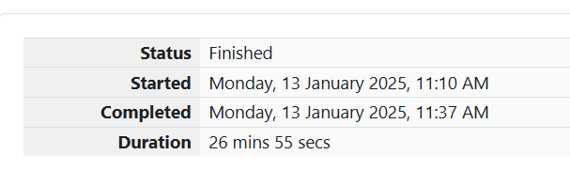
1. Problem Statement: Boxes through a Tunnel
You are transporting some boxes through a tunnel, where each box is a parallelepiped, and is characterized by its length, width, and height. The height of the tunnel is 41 feet, and the width can be assumed to be infinite. A box can be carried through the tunnel only if its height is strictly less than the tunnel's height. Find the volume of each box that can be successfully transported to the other end of the tunnel.
Note: Boxes cannot be rotated.
Input Format:
- The first line contains a single integer n, denoting the number of boxes.
- Each of the following n lines contains three integers separated by single spaces representing the length, width, and height in feet of the box.
Constraints:
- 1 ≤ n ≤ 100
- 1 ≤ length, width, height ≤ 100
Output Format:
For every box with a height less than 41 feet, print its volume in a separate line.
Sample Input:
Copy code
4
5 5 5
1 2 40
10 5 41
7 2 42
Sample Output:
Copy code
125
80

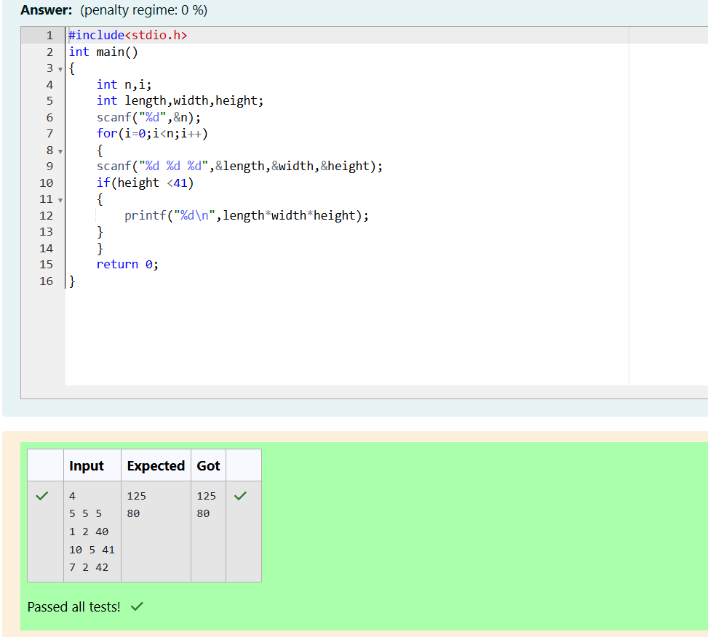
2. Problem Statement: Small Triangles, Large Triangles
You are given an array of triangles. Each triangle is characterized by its three sides a, b, and c. The task is to sort the triangles in ascending order of their areas. If two triangles have the same area, they should appear in the same order as they were provided in the input.
Input Format:
- The first line contains an integer n, the number of triangles.
- The next n lines contain three space-separated integers a, b, and c, denoting the sides of each triangle.
Output Format:
Print n lines, each containing three space-separated integers denoting the sides of the triangles in ascending order of their areas.
Constraints:
- 1 ≤ n ≤ 100
- 1 ≤ a, b, c ≤ 1000
- The sum of the lengths of any two sides will always be greater than the length of the third side.
Note:
The area of a triangle with sides a, b, and c is given by Heron's formula:
scss
Copy code
Area = sqrt(s * (s - a) * (s - b) * (s - c))
Where s = (a + b + c) / 2 is the semi-perimeter.
Sample Input:
Copy code
3
7 24 25
5 12 13
3 4 5
Sample Output:
Copy code
3 4 5
5 12 13
7 24 25

